February 24, 2019

Here are a few graphs and tables to update the last bit of sampling (samples collected through February 19, 2019).

Take home: Y_SM variance has continued to stay below mean. Even though there have not been a lot of samples on Y_SM, this has been a consistent result. N_SM has highest variance. Y_NA and N_NA are too similar in mean and too high in variance to detect difference with much power no matter how much sampling occurs based on what I’ve seen so far. See Figures 1 and 3 for good examples of this.

These tables and estimates are different from earlier summaries because of additional sampling. Also, for a few sites a bar would have been sampled on two different days. Earlier I kept the code separate by bar and day. I’m collapsing by day now as well.

Next steps will be to work on the double observer data and to re-do the GLM analyses using counts as the response and controlling for effort as an offset. Will be building new covariates for the GLM analyses.

To review the naming, we are sampling with strata defined by whether the area is open or closed to fishing (Y/N) or the status of rocks (Large [LG], Small [SM], or wild without rocks [NA].

Possible strata

Strata Description

N_LG No harvest, large rock

N_NA No harvest, no rock (wild bar)

N_SM No harvest, small rock

Y_NA Yes harvest, no rock

Y_SM Yes harvest, small rock (has not been sampled)

Y_LG Yes harvest, large rock (not a possibility as large rocks only used in closed harvest areas)

This is what these data from winter 2018-2019 look like (data1 from data processing script). These are the “collapsed” transects such that multiple transects on an individual bar are pooled, even if collected across multiple days. I’ve checked the strata against Steve’s list but should be checked again.

|  |  |  |  |  |  |  |  |  |  |  |  |
| --- | --- | --- | --- | --- | --- | --- | --- | --- | --- | --- | --- |
| obs | season | treatment | locality | site | bar | station | count_live | tran_length | Area m^2 | Density m^2 | strata |
| 1 | Winter | control | BT | I | 1 | BTI1 | 897 | 23 | 3.5052 | 255.905511811024 | N_NA |
| 2 | Winter | control | BT | I | 2 | BTI2 | 1108 | 38.65 | 5.89026 | 188.107146373844 | N_NA |
| 3 | Winter | control | BT | I | 3 | BTI3 | 1326 | 39.9 | 6.08076 | 218.064847157263 | N_NA |
| 4 | Winter | control | BT | I | 4 | BTI4 | 627.5 | 55.8 | 8.50392 | 73.7894994308507 | N_NA |
| 5 | Winter | control | BT | I | 5 | BTI5 | 3988 | 62.69 | 9.553956 | 417.418711160068 | N_NA |
| 6 | Winter | control | BT | I | 6 | BTI6 | 815.5 | 17.75 | 2.7051 | 301.467598240361 | N_NA |
| 7 | Winter | control | LC | I | 1 | LCI1 | 1650 | 45.39 | 6.917436 | 238.527685691635 | N_NA |
| 8 | Winter | control | LC | I | 10 | LCI10 | 1686 | 38.2 | 5.82168 | 289.607123716865 | Y_NA |
| 9 | Winter | control | LC | I | 11 | LCI11 | 302 | 17.86 | 2.721864 | 110.953376068753 | Y_NA |
| 10 | Winter | control | LC | I | 12 | LCI12 | 1106 | 36.09 | 5.500116 | 201.086667990275 | Y_NA |
| 11 | Winter | control | LC | I | 13 | LCI13 | 3421.5 | 71.3 | 10.86612 | 314.877803668651 | Y_NA |
| 12 | Winter | control | LC | I | 14 | LCI14 | 1501 | 22.75 | 3.4671 | 432.926653399094 | Y_NA |
| 13 | Winter | control | LC | I | 15 | LCI15 | 638 | 20.8 | 3.16992 | 201.266908944074 | Y_NA |
| 14 | Winter | control | LC | I | 16 | LCI16 | 427.5 | 24.04 | 3.663696 | 116.685445517314 | Y_NA |
| 15 | Winter | control | LC | I | 17 | LCI17 | 189 | 14.65 | 2.23266 | 84.6523877348096 | Y_NA |
| 16 | Winter | control | LC | I | 18 | LCI18 | 1813 | 68.16 | 10.387584 | 174.535291363227 | Y_NA |
| 17 | Winter | control | LC | I | 19 | LCI19 | 153 | 22.21 | 3.384804 | 45.2020264688886 | Y_NA |
| 18 | Winter | control | LC | I | 2 | LCI2 | 1534 | 32.2 | 4.90728 | 312.596794965847 | Y_NA |
| 19 | Winter | control | LC | I | 3 | LCI3 | 1104 | 23.8 | 3.62712 | 304.373717991133 | Y_NA |
| 20 | Winter | control | LC | I | 4 | LCI4 | 1909 | 22.5 | 3.429 | 556.722076407116 | Y_NA |
| 21 | Winter | control | LC | I | 5 | LCI5 | 942 | 20.4 | 3.10896 | 302.995213833565 | Y_NA |
| 22 | Winter | control | LC | I | 6 | LCI6 | 454 | 21.5 | 3.2766 | 138.558261612647 | Y_NA |
| 23 | Winter | control | LC | I | 7 | LCI7 | 853 | 21.66 | 3.300984 | 258.407795978411 | N_NA |
| 24 | Winter | control | LC | I | 8 | LCI8 | 96 | 19 | 2.8956 | 33.1537505180274 | Y_NA |
| 25 | Winter | control | LC | I | 9 | LCI9 | 695 | 22.24 | 3.389376 | 205.05249343832 | Y_NA |
| 26 | Winter | control | LC | N | 1 | LCN1 | 109 | 29.86 | 4.550664 | 23.9525484632572 | Y_NA |
| 27 | Winter | control | LC | N | 2 | LCN2 | 693 | 32.77 | 4.994148 | 138.762407521763 | Y_NA |
| 28 | Winter | control | LC | N | 3 | LCN3 | 146 | 19.9 | 3.03276 | 48.1409673037101 | Y_NA |
| 29 | Winter | control | LC | N | 4 | LCN4 | 35 | 22 | 3.3528 | 10.4390360295872 | Y_NA |
| 30 | Winter | control | LC | N | 5 | LCN5 | 700 | 21.75 | 3.3147 | 211.18049898935 | Y_NA |
| 31 | Winter | control | LC | N | 6 | LCN6 | 2275 | 32.4 | 4.93776 | 460.735232170053 | Y_NA |
| 32 | Winter | control | LC | N | 7 | LCN7 | 611 | 13.3 | 2.02692 | 301.44258283504 | Y_NA |
| 33 | Winter | control | LC | N | 8 | LCN8 | 58 | 17.5 | 2.667 | 21.7472815898013 | Y_NA |
| 34 | Winter | control | LC | N | 9 | LCN9 | 4 | 36.12 | 5.504688 | 0.726653354377214 | Y_NA |
| 35 | Winter | rocks | LC | O | 10A | LCO10A | 1619 | 113.4 | 17.28216 | 93.6804195771825 | N_LG |
| 36 | Winter | rocks | LC | O | 11B | LCO11B | 276 | 66.77 | 10.175748 | 27.123313195256 | N_LG |
| 37 | Winter | rocks | LC | O | 12 | LCO12 | 358.5 | 111.86 | 17.047464 | 21.0295208718435 | N_LG |
| 38 | Winter | rocks | LC | O | 14 | LCO14 | 4612 | 70.11 | 10.684764 | 431.642664264742 | N_SM |
| 39 | Winter | rocks | LC | O | 15 | LCO15 | 3390.5 | 169.84 | 25.883616 | 130.9901985874 | N_SM |
| 40 | Winter | rocks | LC | O | 16 | LCO16 | 52 | 22.95 | 3.49758 | 14.8674226179244 | N_SM |
| 41 | Winter | rocks | LC | O | 17 | LCO17 | 209 | 45.37 | 6.914388 | 30.2268255701011 | Y_SM |
| 42 | Winter | rocks | LC | O | 19 | LCO19 | 557.5 | 116.31 | 17.725644 | 31.4516076256524 | Y_SM |
| 43 | Winter | rocks | LC | O | 2 | LCO2 | 945 | 20.86 | 3.179064 | 297.257305924008 | N_LG |
| 44 | Winter | rocks | LC | O | 20 | LCO20 | 385 | 87.12 | 13.277088 | 28.9973223044089 | Y_SM |
| 45 | Winter | rocks | LC | O | 21 | LCO21 | 714 | 129.01 | 19.661124 | 36.3153195107258 | Y_SM |
| 46 | Winter | rocks | LC | O | 3 | LCO3 | 358 | 18.02 | 2.746248 | 130.359676183651 | N_LG |
| 47 | Winter | rocks | LC | O | 4 | LCO4 | 953 | 22.1 | 3.36804 | 282.953884158145 | N_LG |
| 48 | Winter | rocks | LC | O | 8A | LCO8A | 319 | 15.2 | 2.31648 | 137.708937698577 | N_LG |
| 49 | Winter | rocks | LC | O | 9B | LCO9B | 674.5 | 115.78 | 17.644872 | 38.226403682611 | N_LG |
| 50 | Winter | rocks | LC | O | 9C | LCO9C | 1161 | 111.2 | 16.94688 | 68.5081855775222 | N_LG |
| 51 | Winter | control | LT | I | 1 | LTI1 | 692 | 29.8 | 4.54152 | 152.371893110677 | N_NA |
| 52 | Winter | control | LT | I | 2 | LTI2 | 190 | 22.68 | 3.456432 | 54.9699806042763 | N_NA |
| 53 | Winter | control | LT | I | 3 | LTI3 | 883 | 37.5 | 5.715 | 154.505686789151 | N_NA |
| 54 | Winter | control | LT | I | 4 | LTI4 | 1323 | 34.84 | 5.309616 | 249.170561486932 | N_NA |
| 55 | Winter | control | LT | I | 5 | LTI5 | 1412 | 38.75 | 5.9055 | 239.099144864956 | N_NA |
| 56 | Winter | control | LT | I | 6 | LTI6 | 594 | 18.87 | 2.875788 | 206.55208242054 | N_NA |
| 57 | Winter | control | NN | I | 1 | NNI1 | 233.5 | 14.5 | 2.2098 | 105.665671101457 | N_NA |
| 58 | Winter | control | NN | I | 2 | NNI2 | 911 | 22.85 | 3.48234 | 261.605701913081 | N_NA |
| 59 | Winter | control | NN | I | 3 | NNI3 | 156 | 33 | 5.0292 | 31.0188499164877 | N_NA |
| 60 | Winter | control | NN | I | 4 | NNI4 | 571 | 13.3 | 2.02692 | 281.708207526691 | N_NA |
|  |  |  |  |  |  |  |  |  |  |  |  |

Table of total transect length sampled (m) by strata

|  |  |
| --- | --- |
| strata | total tran length sampled (m) |
| N_LG | 595.19 |
| N_NA | 570.93 |
| N_SM | 262.9 |
| Y_NA | 723.3 |
| Y_SM | 377.81 |
|  |  |

Counts of individual transects to check to see if match white board (Steve’s counts). They seem to match.

|  |  |
| --- | --- |
| Strata | Frequency of transects |
| N_LG | 27 |
| N_NA | 25 |
| N_SM | 12 |
| Y_NA | 29 |
| Y_SM | 17 |

Number of collapsed transects. This totals 60 which are the 60 rows in the data file on the previous page.

|  |  |
| --- | --- |
| strata | number_collapsed_trans |
| N_LG | 9 |
| N_NA | 18 |
| N_SM | 3 |
| Y_NA | 26 |
| Y_SM | 4 |

Mean length (m) of collapsed transects. I probably should be reporting the area and not the length, but as the width is fixed it is just a relative scaler.

|  |  |
| --- | --- |
| strata | mean_tran_length |
| N_LG | 66.13 |
| N_NA | 31.72 |
| N_SM | 87.63 |
| Y_NA | 27.82 |
| Y_SM | 94.45 |

Variance in length of collapsed transects

|  |  |
| --- | --- |
| strata | var_tran_length |
| N_LG | 2214.87 |
| N_NA | 192.5 |
| N_SM | 5624.47 |
| Y_NA | 196.97 |
| Y_SM | 1378.28 |

Figure 1. A graph of oyster density (m^2) by station color and shape coded by strata.

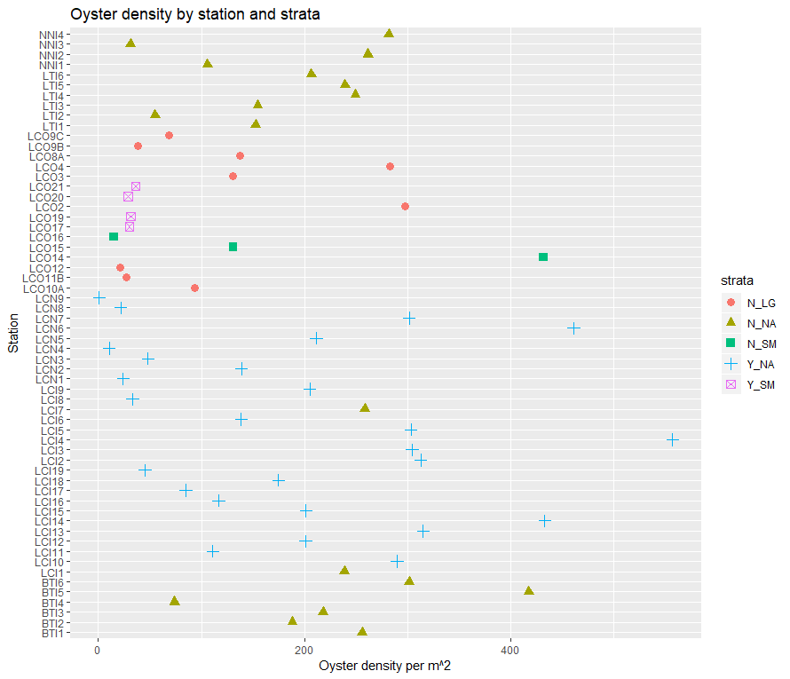

This is important because it shows the “spread” within each strata (shape and color). So for Y_NA the density estimates are highly variable, that’s why there is a huge spread. Compare that to Y_SM (only 4 samples taken). N_NA seems to perhaps be falling out a little bit between BTI complex and NN/LT complex. You can sort of see this bifurcation in the histogram in the next plot. This is where the spatial autocorrelation in the samples will be important to incorporate.

Figure 2. Histogram of oyster density (m^2) in each collapsed transect by strata.

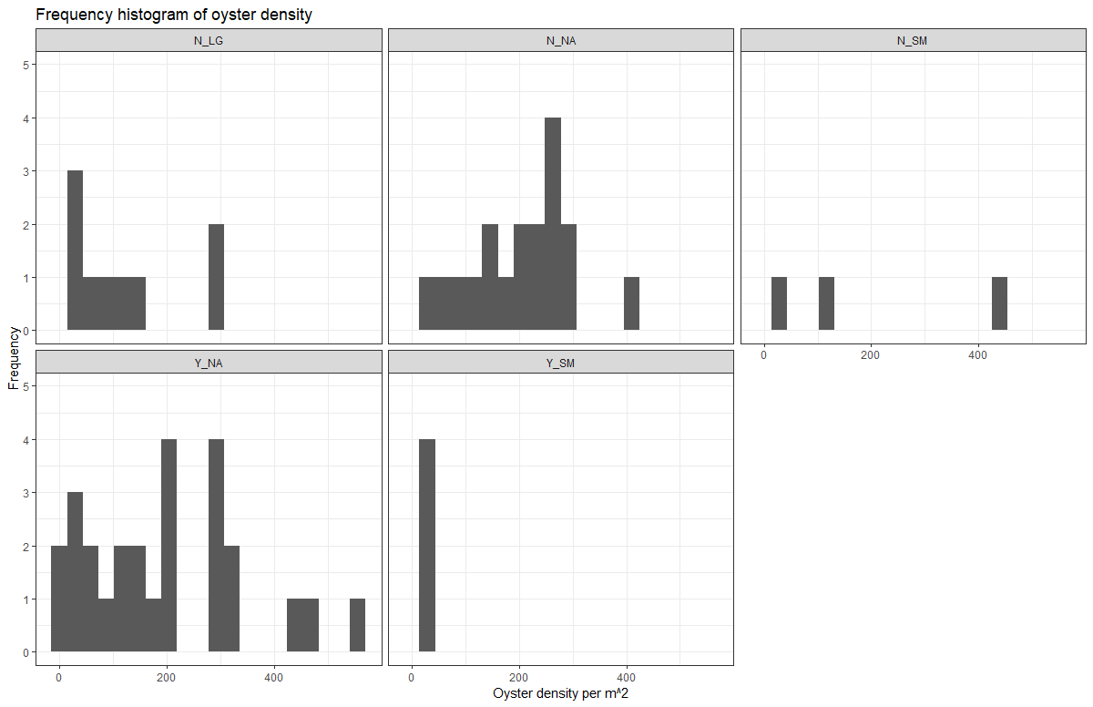

Simple summary stats of oyster density (per m^2) overall (all strata combined)

|  |  |  |  |  |  |  |  |  |  |  |  |
| --- | --- | --- | --- | --- | --- | --- | --- | --- | --- | --- | --- |
| NobsTotal | Mean | Median | Sd | Var | CV | Se | L95se | U95se | Bstrapmean | L95bstrap | U95bstrap |
| 60 | 175.53 | 153.44 | 132.51 | 17559.81 | 0.75 | 17.11 | 142 | 209.07 | 175.48 | 142.77 | 208.02 |

Simple summary stats by strata of oyster density (per m^2). Note I calculate t-test based confidence intervals and bootstrap based intervals. Note the negative value for the lower 95 confidence intervals for N_SM. That’s because it is not normally distributed – that’s why I calculate bootstrap CI.

|  |  |  |  |  |  |  |  |  |  |  |  |  |
| --- | --- | --- | --- | --- | --- | --- | --- | --- | --- | --- | --- | --- |
| .id | NobsTotal | Mean | Median | Sd | Var | CV | Se | L95se | U95se | Bstrapmean | L95bstrap | U95bstrap |
| N_LG | 9 | 121.87 | 93.68 | 104.17 | 10851.97 | 0.85 | 34.72 | 53.81 | 189.93 | 120.04 | 61.28 | 186.87 |
| N_NA | 18 | 204.91 | 228.3 | 96.66 | 9343.38 | 0.47 | 22.78 | 160.25 | 249.56 | 204.53 | 157.53 | 247.64 |
| N_SM | 3 | 192.5 | 130.99 | 215.09 | 46263 | 1.12 | 124.18 | -50.9 | 435.9 | 198.86 | 14.87 | 431.64 |
| Y_NA | 26 | 193.94 | 187.81 | 150.2 | 22560.13 | 0.77 | 29.46 | 136.2 | 251.67 | 193.14 | 137.96 | 253.92 |
| Y_SM | 4 | 31.75 | 30.84 | 3.21 | 10.28 | 0.1 | 1.6 | 28.61 | 34.89 | 31.62 | 29.6 | 34.79 |

Figure 3. Box plot of oyster density (m^2) by strata (using ggplot style for fun). I turned this box plot “on its side” so density is on the “x” and the graph orients such that zero is bottom left. Other box plot aspects are the same. Look at the strange shape of these box plots. Remember how to interpret a box plot, these are not confidence intervals. The top/bottom of the box tells you that 25% of the data are greater than this value. So the top of the box is the upper quartile and the bottom of the box is the lower quartile. The median line inside the box tells you that 50% of the data are greater than this value. The top/bottom of the whisker are the greatest value excluding outliers. Outliers are defined as dots above the whisker and those are 1.5 times the upper quartile.

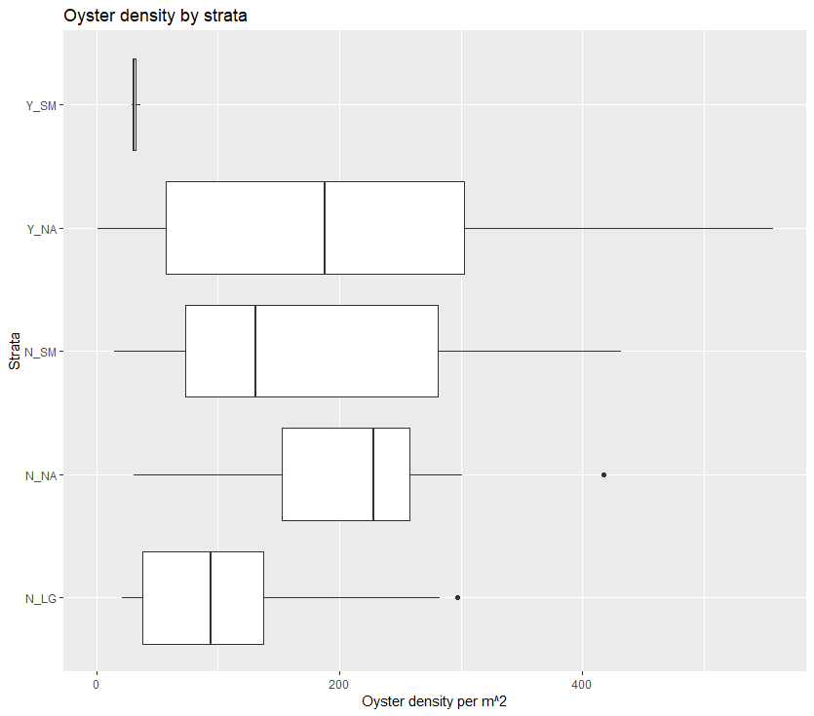

Figure 4. Boxplot of density overall.

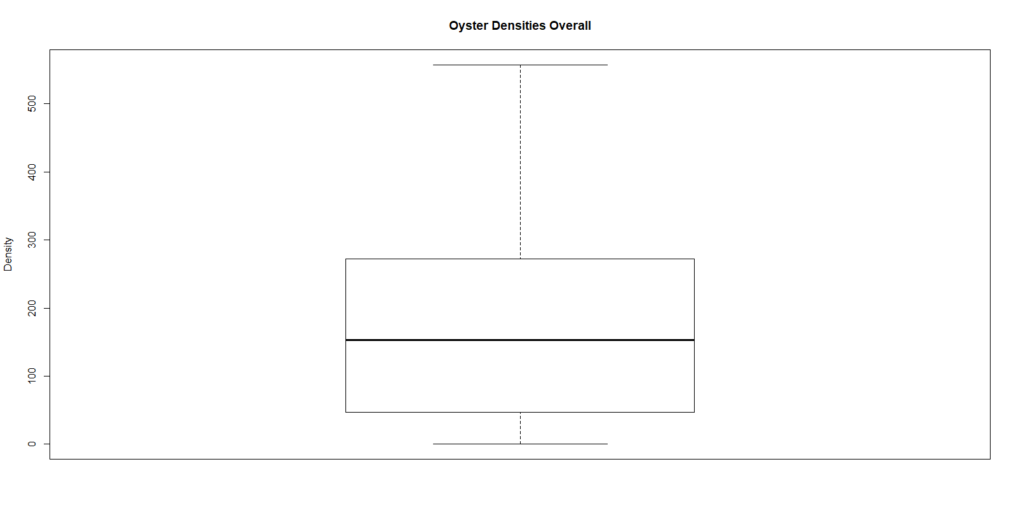

Figure 5. Boxplot of oyster density by locality.

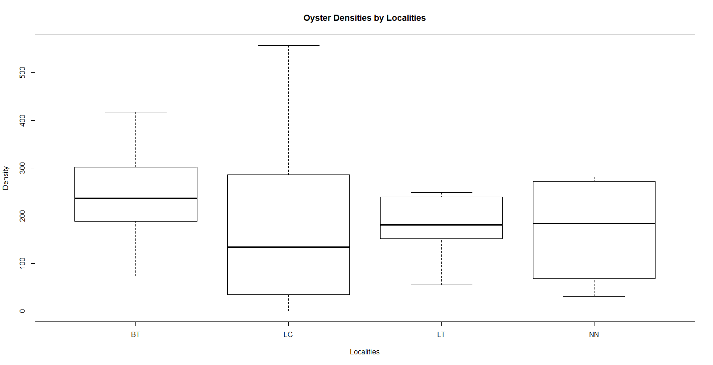

Figure 6. Boxplot of oyster density by treatment.

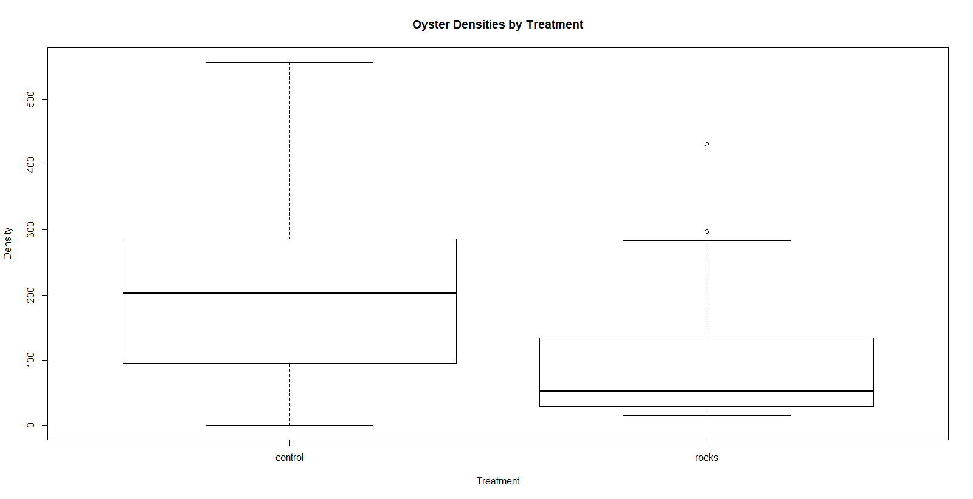

Figure 7. Boxplot oyster densities by site.

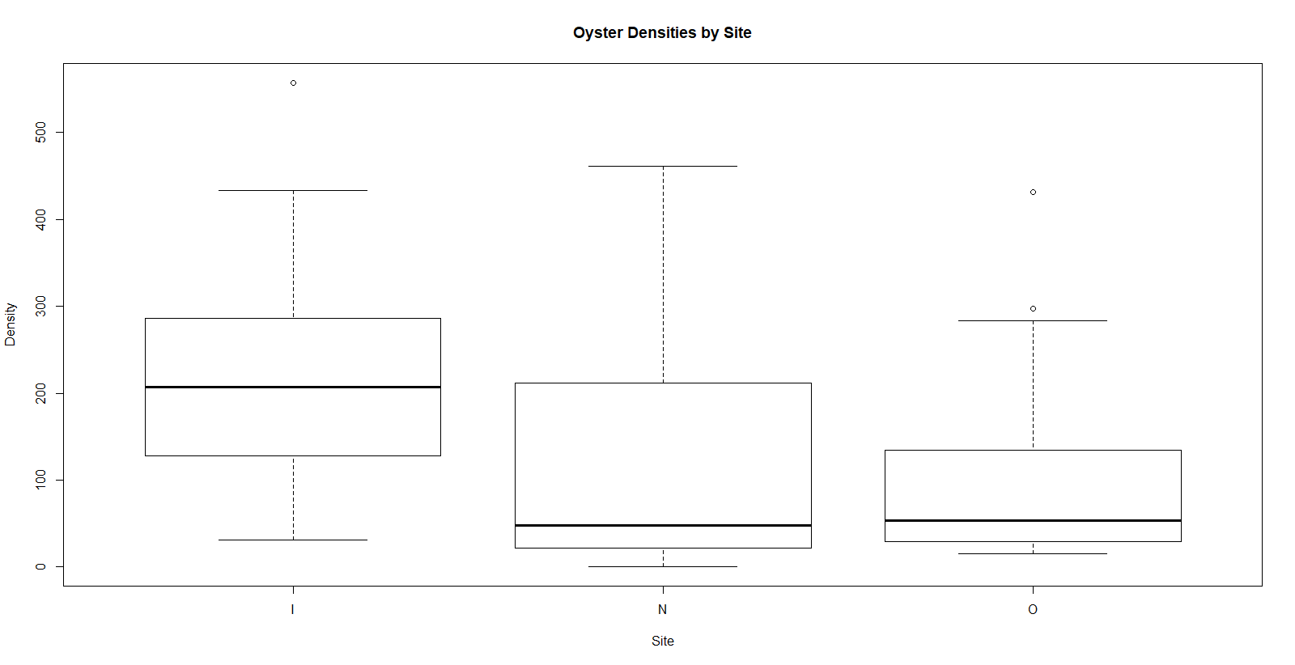

Figure 8. Histogram of collapsed transect lengths (m).

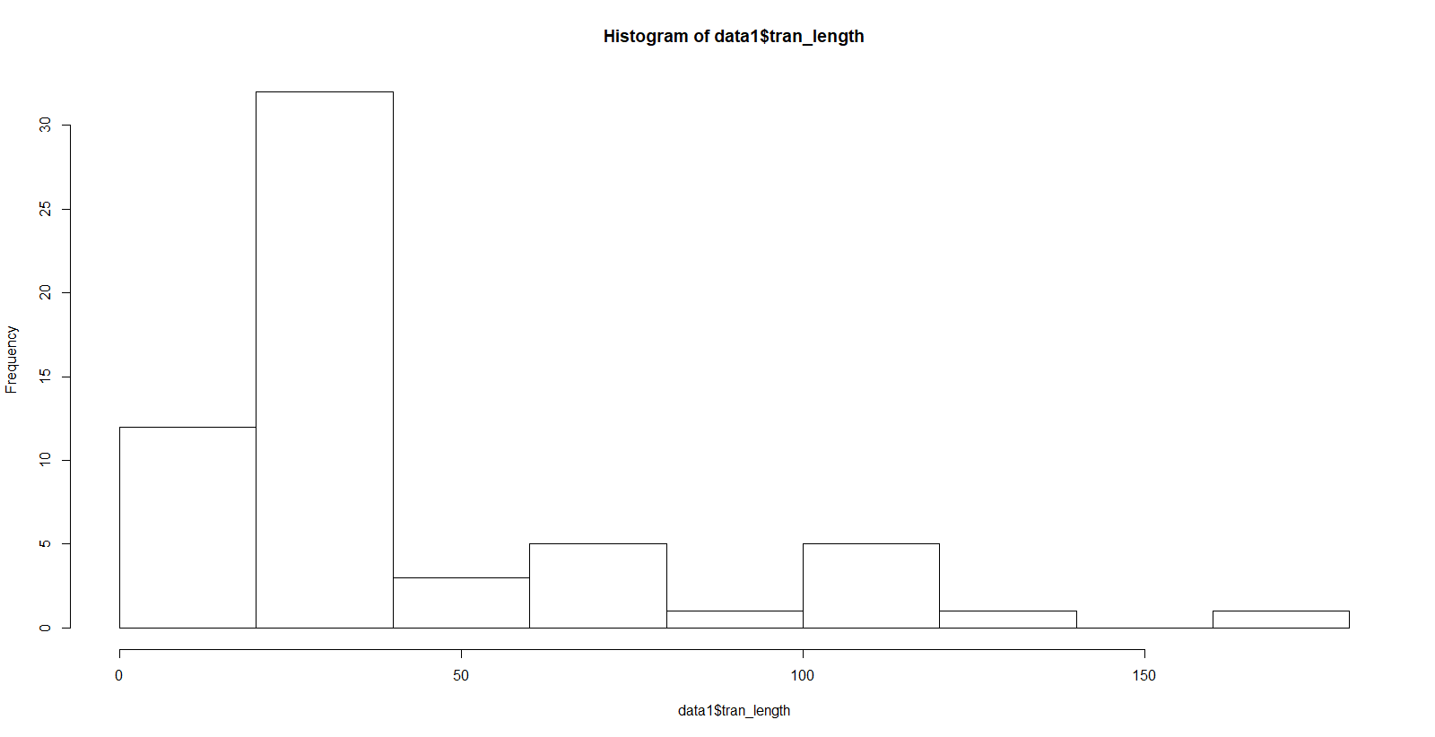

Figure 9. Histograms of collapsed transect length by locality

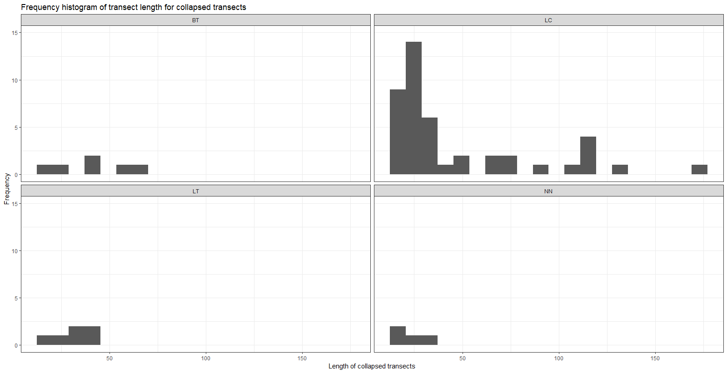

Figure 10. Histogram of collapsed transect lengths by strata

